Nepal College of Information Technology
Assessment Fall 2013

Program : BE (IT) Time : 3 hrs
Semester : Fall (I) FM : 100
Subject : Electronic Circuits and Instrumentation PM: 50

- Candidates are requested to give their answer as far as practicable in their own words.
- The figure in the margin indicates the full marks
- Attempt ALL question
1. a Describe frequency response of amplifier explaining the effect of shunt capacitance on high frequency response of amplifier. [8]
b Find overall voltage gain (VL/Vs) in dB and show all its values in equivalent circuit of circuit below. (Assume re= 25Ω, β = 100, rc = 10 kΩ) [7]
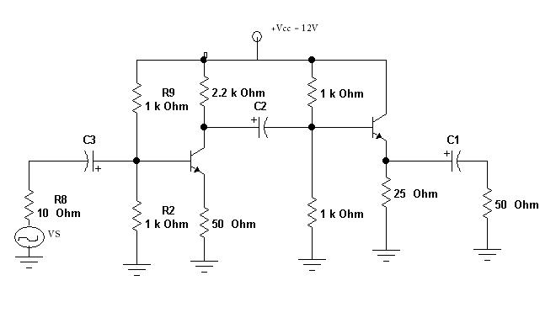
2. a Why efficiency of transformer coupled Class A amplifier greater than that of series-fed class A amplifier? Explain Transformer Coupled Push-Pull amplifier with neat waveform. [2+6]
b Explain voltage –series negative feedback connection [8]
3. a Justify the statement “Negative feedback improves SNR”. Design a Wien- bridge oscillator that oscillates at 25 KHz. [4+4]
b. Figure shows a comparator circuit having non-inverting voltage of +6V and inverting voltage is a sinusoidal input Vi. The output voltage V0 = ± 15V. Draw the output waveform. Design an operational amplifier that produces an output equal to V₀ = 6V1 -4V2 + 3V3 – 5V4. [3+4]
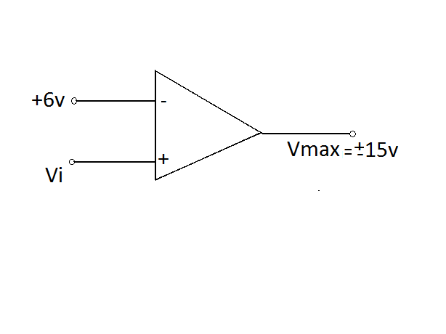
4. a Describe an astable multivibrator circuit with neat diagram. [8]
b. Explain various physical variables and their types. [7]
5. a How can you measure the value of unknown inductance by using Maxwell’s bridge circuit? Explain with limitation. [6+2]
b Explain the components of Instrumentation System in detail. [7]
6. a. Define error and its types. An instrument measures 10 different voltage readings 10.2, 10.8 ,10.3 , 10.5 , 10 , 10.9 ,10.7 , 11 , 10.6. 10.1 V . Find Mean, Standard deviation, variance . [4+4]
b Explain R-2R ladder type DAC in detail. [7]
7. Write short notes on (Any Two) 5*2 =10
i. Cross-Over Distortion
ii. Ideal Characteristics of op-Amp
iii. Types of signals in instrumentation system

